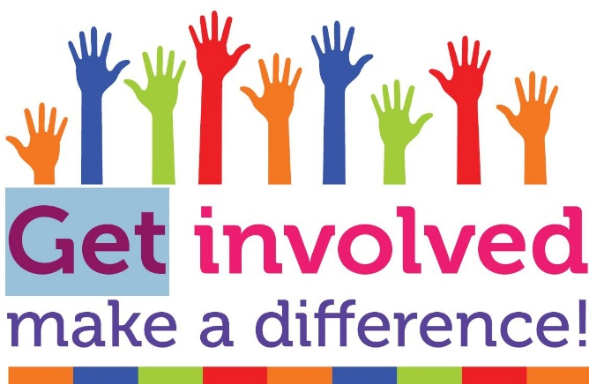

News from your
Patient Participation
Group

Mental Health Practitioners



Mental health professionals in general practice use a range of methods to help people with mental health conditions. These range from talking therapies for common conditions such as stress, anxiety and depression and support for people with more complex needs such as bipolar, psychosis and eating disorders.

They can help by:
- Carrying our assessments.
- Providing advice and support to manage your condition.
- Supporting you to access appropriate mental health services and community resources.

Occupational Therapists

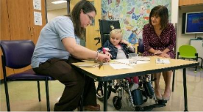

Occupational Therapists support people of all ages with problems resulting from physical, mental, social, or development difficulties. They help people to find ways to continue with everyday activities that are important to them. This could involve learning new ways to do things or making changes to their environment to make things easier.

They can help by:
- Providing rehabilitation for you to stay well at home.
- Empowering you to make improvements in your day-to-day life.
- Supporting you to take control of your health and wellbeing.

Let’s Talk About ….

If you are travelling abroad the practice can give you general advice about travel vaccinations and travel health. If you would like advice or believe that you may need one or more vaccinations before you travel, contact Elvington Medical Practice (EMP) via the website at least 12 weeks before you travel. Initially a specialist nurse will arrange a telephone appointment to discuss your plans, your medical history and what, if any, vaccinations you will need. If you are a family travelling each adult will need a separate telephone appointment. These calls typically last about 10 minutes. Following these calls you will be booked in for any vaccines that you need and which EMP can provide.

Elvington Medical Practice provides those travel vaccinations which are available free on the NHS. These are:
- Polio (given as a combined diptheria/tetanus/POLIO jab)
- Typhoid
- Hepatitis A
- Cholera
These vaccines are free because they protect against diseases thought to represent the greatest risk to public health if they are brought into the country.

You will have to pay for travel vaccinations against:
- Hepatitis B
- Japanese encephalitis
- Meningitis
- Rabies
- Tick borne encephalitis
- TB
- Yellow Fever
- Malaria (given through a course of tablets)

Yellow Fever vaccines are only available from designated centres details of which can be found on the NHS website (www.nhs.uk/conditions/travel/vaccinations)
If you are unsure about which, if any, vaccines you need for individual countries the NHS website (and others, eg www.travelhealthpro.org.uk) carry full details of what is needed.

EMP has a very detailed information leaflet about travel health advice. Vaccination against disease is important but you may wish to know, for example, if it is safe to swim at your destination, if it is safe to drink the water, what foods to avoid, what personal hygiene measures may be more important than they may be at home and what to do if you suffer from travellers diarrhoea ( the most common illness travellers are exposed to and for which there is no vaccine ). You can travel well prepared and the information leaflet available from the practice will help you achieve this and hopefully help you enjoy your holiday free from any health issues.

Travel Advice
Breast Cancer Care
Tub to Pub 2026
Thank you to everyone who has donated their clean unwanted or unloved bras for Breast Cancer Care. Your Patient Participation Group are continuing to support this initiative. You can still pop them in the bin sitting in the reception doorway. Many thanks for your continued support.
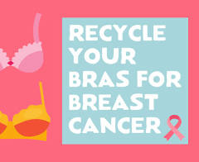


Thank you to everyone who dropped off their plastic tubs for Macmillan Cancer Support in January and February. We had an amazing response.

Mental Health Awareness Week 2026 takes place from 11-17 May, serving as a UK-wide campaign led by the Mental Health Foundation to tackle stigma and promote good mental health. The week features community-focused events, including Wear it Green Day on Thursday 14th May, aimed at encouraging public action, connection, and supporting mental wellness.
The theme this year is Action because, while awareness is vital, real change comes when we take action too. Together, we’ve come a long way on mental health, but we can’t risk going backwards. There’s still much we can do to prevent people becoming unwell in the first place.
Raising awareness is vital, but real change comes when we take action too.

Mental Health Awareness Week – 11th -17th May 2026
Thursday 14th May 2026
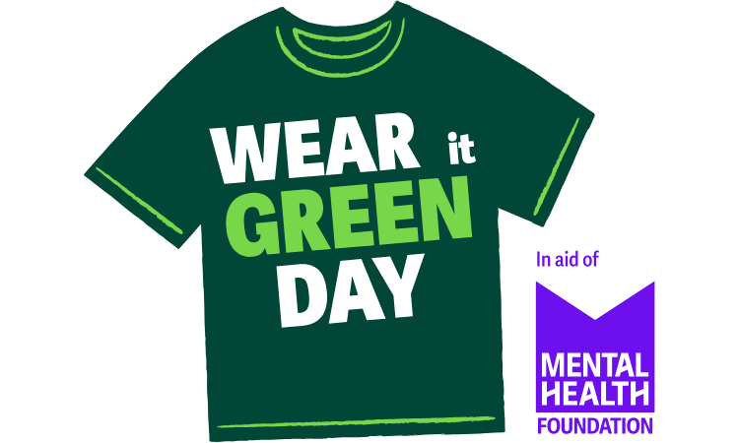
Take ACTION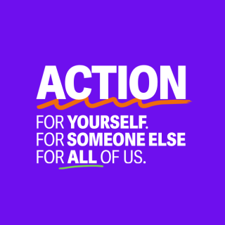
HAYFEVER
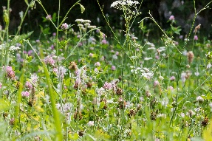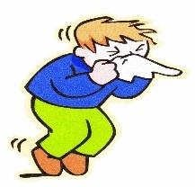
Hay Fever is an Allergic condition and can affect up to 1 in 5 people at some point in their life. You’ll experience Hay Fever symptoms if you have an allergic reaction to Pollen.
Pollen is a fine powder released by Plants as part of their reproductive cycle. It can cause the Nose, Eyes, Throat and Sinuses to become swollen, irritated and inflamed.
You can have an Allergy to one or all of the following:
- Tree Pollen is released during Spring
- Grass Pollen is released during the end of Spring and beginning of Summer
- Weed Pollen, released late Autumn
Many people find their symptoms improve as they get older.
Hay Fever is sometimes called Allergic Rhinitis which can also be triggered from Dust Mites and Mould Spores.
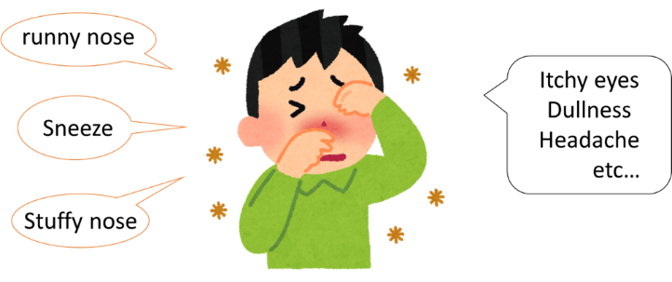
Symptoms
The symptoms of Hay Fever can include:
- Sneezing
- Runny or Blocked Nose
- Itchy, Red or Watery Eyes
- An Itchy Throat, Mouth, Nose and Ears
- A Cough caused by the Mucus dripping down the Throat from the back of the Nose
If you are an Asthma Sufferer your Asthma may get worse when you have Hay Fever.

Treatment
Unfortunately, there isn’t currently a cure for Hay Fever, but most people can relieve their Symptoms with over-the-Counter Medication from a Pharmacy. One treatment option is using Antihistamines. A Pharmacist will advise you what best to take, depending on what other Medications you take.
The most effective way to control Hay Fever would be to avoid exposure to Pollen. However, it’s not always very easy to avoid Pollen, particularly during the summer months.

Who’s affected?
You can get Hay Fever at any age, but it usually begins in Childhood or during your teenage years. It’s more common in Boys than Girls but as Adults, Men and Women are equally affected. You are more likely to develop Hay Fever if there is a family history of Allergies, particularly Asthma or Eczema

Symptom Prevention
It’s sometimes possible to prevent the symptoms of Hay Fever by taking some basic precautions.
- Wear Wraparound Sunglasses to stop Pollen getting in your Eyes when you’re Outdoors
- Take a Shower and change your Clothes after being Outdoors to remove any Pollen on your Body
- Stay Indoors when the Pollen Count is at its Highest
- Apply a small amount of Petroleum Jelly (Vaseline) to the Nostrils to trap Pollen.

.

